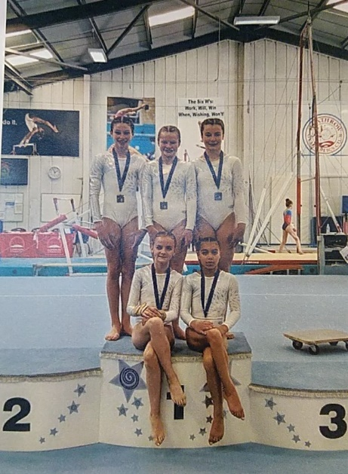

Mayfield Gymnastics Club Newsletter Autumn 2019

“Success is a peace of mind, which is a result of self-satisfaction in knowing you did your best to become the best you are capable of becoming“

Everyone at Mayfield gymnastics Club would like to wish a warm welcome back to our current gymnasts, the new starters and thank all for your continued support.

On reflection of the major works which surrounded our gym at the beginning of the year, we would like to thank everyone for your patience and co-operation as we found our way to the new entrance and car park settling in well and happy.

Key Dates

Term dates

3rd September – 21st December 2019

Parents watching week

17th -21st December 2019

*Mayfield Gymnastics Club Annual Competition - 13th April 2019*

Well done to everyone who took part, the results are as follows

**GOLD**

Lara Hills, Thea Huw Williams, Alexandra Gray, Isabelle Charash & Filippa Berthiot-Wissinger

**SILVER**

Xanthe Stokes, Poppy Pandya, Sasha Rog, Poppy Richards & Evie Templeman

**BRONZE**

Laura Turnbull, Lauren Hallsworth, Belle Beecher, Mila Henkes & Arabella Shaw

**Competition Announcements 2019**

Our Senior Team competed in The London Regional Team Championships and we are proud to announce they won the Gold Medal. Well done to Aimee, Chloe, Isla, Madeleine and Romilly